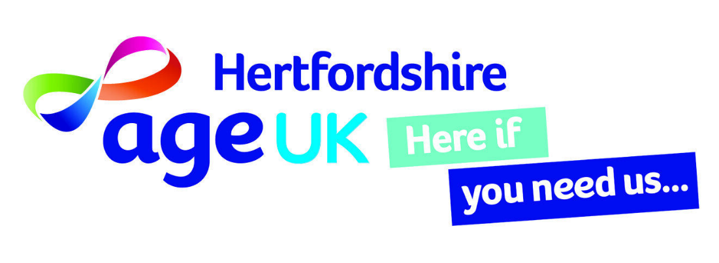

**WINTER WELFARE REFERRAL FORM**

This is a vital opportunity for AGE UK Hertfordshire to engage with residents in hardship and possible distress over the colder months and an opportunity to make a real difference. Please consider if the referral being made is a nice to have or an important must have for a resident. We will, where possible carry out desk research and contact the resident before visiting to help prioritise the severity of the residents needs as further agencies or organisations may need to be involved.

Please complete **all parts** of this referral including the demographical information asked for at the end.

|  |  |  |  |  |  |
| --- | --- | --- | --- | --- | --- |
| PROSPECTIVE CLIENT: | | | | | |
| Title: | First Name: | | | Surname: | | |
| Address (Please Print): | | | | | | |
|  | | | | | | |
| Town: |  | | | | Post code: | |
| D.O.B: |  | | | |  | |
| Ethnicity (please see overleaf) |  | | | |  | |
| Gender: |  | | | |  | |
| Tel No: |  | | | |  | |
| NOK: | | | | | |  |
| Title: | First Name: | | | Surname: | | |
| Address (Please Print): | | | | | | |
|  | | | | | | |
| Town: |  | | | | Post code: | |
| Tel No: |  | | | |  | |
| Reason for referral: | | | Please provide a detailed description | | | |
| Draught excluder “P” Strips | | |  | | | |
| Radiator reflector strip | | |  | | | |
| Energy Efficient Light bulbs – only 1 type – screw-in or bayonet | | |  | | | |
| Electric blanket | | |  | | | |
| Winter Duvet – single. | | |  | | | |
| Warm In Winter Bags supplied by Small Acts of Kindness (hat, socks, gloves, blanket) | | |  | | | |
| Repairs – If any repairs are needed, please be specific as the scope is limited | | |  | | | |
| Night lights | | |  | | | |
| Electric Heaters – oil filled type – will need HP to set up. | | |  | | | |
| Any other information that you feel may be useful, please enter it here: | | |  | | | |
| Has the client given their consent to be contacted? | | | | |  | |
| Does the client live alone? | | | | |  | |
| HEALTH: | | | | | |  |
| Does the client suffer from mental ill health or dementia? | | | |  | | |
| Does the client have any hearing or sight impairment or a physical disability? | | | |  | | |
| Does the client have any alcohol &/or drug issues? | | | |  | | |
| If anyone else is likely to be in the property, do they have a mental &/or physical health disability, drink &/or drug issue? | | | |  | | |
| Is the client a smoker? | | | |  | | |
| Are there any animals on the premises? | | | |  | | |
| If the answer is yes to any of the above marked * please supply further information: | | | | | | |
|  | | | | | | |
| Name & contact details of referrer: | |  | | | | |
| Date: | |  | | | | |

Ethnicity

W1 White British

W2 White Irish

W3 White other

A1 Asian/Asian British/Bangladeshi

A2 Asian/Asian British/Indian

A3 Asian/Asian British/Pakistani

A4 Asian/Asian British/ any other

B1 Black or Black British African

B2 Black or Black British Caribbean

B3 Black British any other background

1 Chinese

3 Traveller

2 Other Ethnic Groups

**Please email this completed document, password protected to:**    
chris.skrabski@ageukherts.org.uk

P-Strip draught excluder. Applied between a door / window and frame .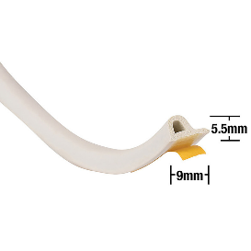

Plug in night light. 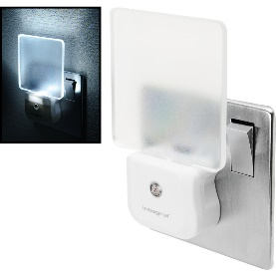

Radiator reflector. 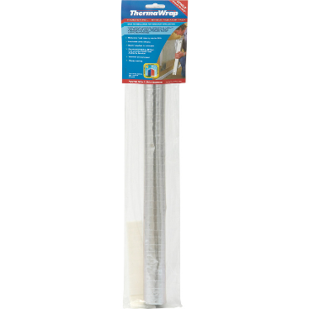

Screw in LED bulbs.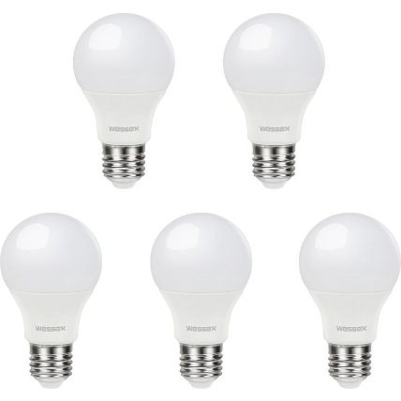

Bayonet LED bulbs. 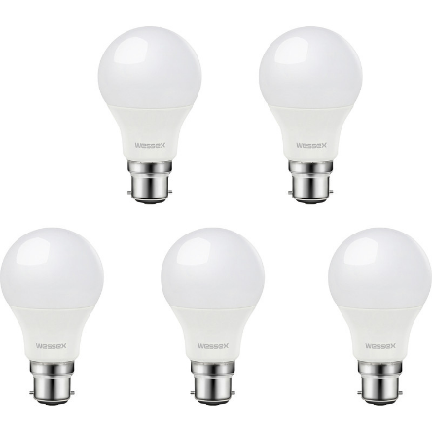

These are all subject to change depending on their availability throughout the duration of the scheme. Where substitutions need to be made, we will try to do so with a close match. Any items that become “unavailable” during the scheme duration, which historically has occurred, we will contact the resident to advise and try to source an alternative.

Age UK Hertfordshire can only advise residents on visits to a resident's home based on current government guidelines as published. For example; “consider turning down the thermostat by a degree” or “consider turning down or off radiators in rooms you don’t use”. We cannot replace the expertise of a Gas safe engineer, plumber or other trade professionals and as such where specific situations or questions arise, we may refer the resident to contact a professional trade.

Within the scope of “D.I.Y.” or what a “reasonable person could do at home”, we will endeavour to make a resident's situation better. This is relative based on the residential accommodation and its condition.

Correct at the time of launch 03/10/2024